Program output screenshots

1. display the menu as below :

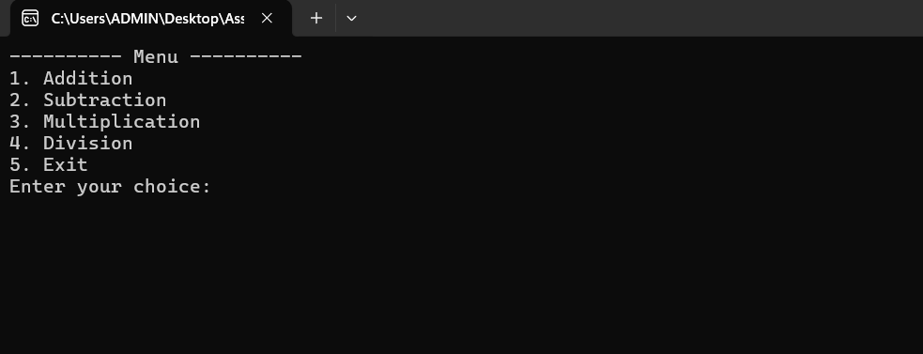

1. perform selected operation as given in below :

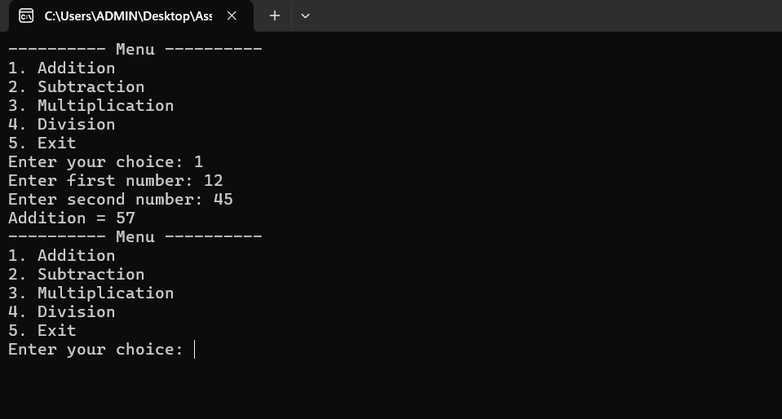

1. user will not select any of the options given in the MENU, then it should not perform any operation and have to display a user friendly message.

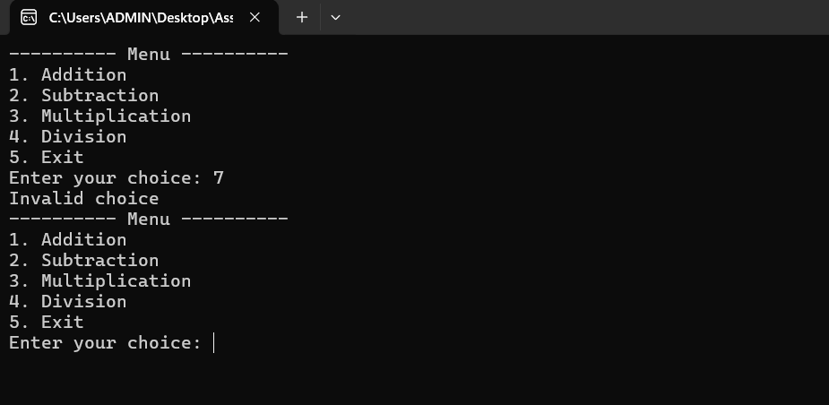



4.Exit program:

